Extrinsic End of Line (EOL) calibration for SVC’s documentation

Marc Deetjen

**Summary of extrinsic calibration methods**

* **2D vanishing point method**
  + Author: David Hsu
  + Summary: previous method. Good for sorting lines into the x or y axis, but poor at accurately finding the vanishing point in the y axis
* **3D vanishing point method**
  + Author: Marc Deetjen
  + Summary: robust initialization of extrinsic rotation matrix by finding 3D vanishing points
  + VP3D_Extrinsics function in ExtrinsicRefinment.cpp
    - Input
      * DatAll[c].Lines_Lab = sorted detected lines based on calibration target axis alignment (from 2D vanishing point method)
      * DatAll[c].Lines_EndPts = detected line endpoints from 2D vanishing point method
      * DatAll[c].CamFC/CamPP = focal length & principal point from intrinsic calibration
      * DatAll[c].Orig_R_A_C = approximate rotation matrix based on manual input from DataProviderVpcs.cpp. This can be very far off from the true rotation matrix (tested up to 10 degrees error, but could go up to 40 theoretically) and still return the correct rotation matrix
    - Output
      * DatAll[c].VP3D_R_A_C = accurate fitted extrinsic rotation matrix from Camera reference frame (C) to cAr reference frame (A)
    - Functionality/algorithm
      * Vanishing points should be visualized in 3D rather than 2D for robust performance (see figure 6). A Summary of the algorithm is presented in figures 7-9. Whichever axis (x or y) has more detected lines is fit first, and then the remaining axis (y or x) is fit second and only requires a single degree of freedom because it is based on the first axis.
* **Refined extrinsic method**
  + Author: Marc Deetjen
  + Summary: robust fine tuning of the extrinsic rotation & translation parameters simultaneously
  + MatchLines function in ExtrinsicRefinment.cpp
    - Input
      * CalibTLines = dimensions of the calibration target. This should be set in MD_VarStore.h and varies from car to car.
      * DatAll[c].Orig_xyz_CamPos = original manually set camera position in the cAr reference frame
      * DatAll[c].VP3D_R_A_C = fitted rotation matrix from 3D vanishing point method
      * DatAll[c].Lines_Lab = sorted detected lines based on calibration target axis alignment (from 2D vanishing point method)
      * DatAll[c].Lines_EndPts = detected line endpoints from 2D vanishing point method
      * DatAll[c].ImUD = undistorted image from the camera corresponding to the detected lines
      * DatAll[c].CamFC/CamPP = focal length & principal point from intrinsic calibration
    - Output
      * std::vector<std::vector<int>> Matches = detected line # corresponding to [x/y aligned] [Calibration target line #]. Value is -1 if there is no match
      * Debug figure (see Figure 5)
    - Functionality/algorithm
      * The 2D detected lines are projected onto the z=0 plane and then matched to the calibration target lines based on the best match.
      * The matched lines must be within Match_MaxOffsetDist = 75 mm. The best match for each calibration target line is found using the following scoring metric: (Line length)^0.5 * (Line color differential)^1.5.
      * The line color differential is the absolute value difference between the average grayscale values of the left & right sides of the detected line. In other words, the line is scored higher for higher contrast between it’s different sides. The sign (+/-) of the differential is used to eliminate half the possible matches (i.e. a detected line with white on the left & black on the right should only be matched to a calibration target line with white on the left & black on the right).
      * Matches are deleted if their score is too low compared to the best match for that camera.
  + RefineExtrinsics function in ExtrinsicRefinment.cpp
    - Input
      * DatAll[c].Orig_xyz_CamPos = original manually set camera position in the cAr reference frame
      * DatAll[c].VP3D_R_A_C = fitted rotation matrix from 3D vanishing point method
      * std::vector<std::vector<int>> Matches = output from MatchLines function
      * DatAll[c].Lines_EndPts = detected line endpoints from 2D vanishing point method
      * DatAll[c].CamFC/CamPP = focal length & principal point from intrinsic calibration
    - Output
      * DatAll[c].Refined_R_A_C = final fitted extrinsic rotation matrix from Camera reference frame (C) to cAr reference frame (A)
      * DatAll[c].Refined_xyz_CamPose = final fitted extrinsic camera positions in the cAr reference frame (A)
    - Functionality/algorithm
      * This algorithm is based on the following paper, with major improvements made by Marc Deetjen: Xu, C., Zhang, L., Cheng, L., & Koch, R. (2017). Pose Estimation from Line Correspondences: A Complete Analysis and a Series of Solutions. IEEE Transactions on Pattern Analysis and Machine Intelligence, 39(6), 1209–1222. https://doi.org/10.1109/TPAMI.2016.2582162. See the section “Get Camera Pose algorithm” below for details.
      * The following variables are tuning parameters to adjust the weighting of the error (W1, WR, and WT in “Get Camera Pose algorithm” below)
        + AveMainErDeg = 0.1; // Max expected error in degrees for the main fitting code
        + AveR_ErDeg = 2.0; // Max expected error for rho R adjustment
        + AveT_ErMM = 30; // Max expected error for T adjustment
        + MainErRatio = 5; // Main error should be this much more weighted on average. LOWER THIS VALUE IF YOU TRUST THE HAND MEASUREMENT OF THE CAMERA POSITION

**Debugging**

* Look at the rainbow debugging image (Figure 5). If there are lines that are matched incorrectly or no matched lines, then look at Fig_BirdsEyeAll(DatAll, CalibTLines, true, 3); If the red & green lines don’t approximately overlap the calibration edges, then modify one of the following:
  + Update the Separation distance between the calibration targets. This is currently the SepDist field in the TargetLines class and is set by SetSepDist. This should equal 2000, 2250, or 2500.
  + Tweak the manually set position of the camera (v_Cfg_s.cVal_ax in DataProviderVpcs.cpp)
  + If the wrong yLine (see Figure 4) is being matched in the rainbow debugging image (Figure 5) and it can’t be solved by tweaking the manually set position of the camera, set the yCamSee variable in the TargetLines class to empty for that camera.

**Summary of reference frame definitions**

* cAr Axle (A) reference frame
  + Origin: center of front axle of the car, on the ground
  + +X direction: backwards
  + +Y direction: right
  + +Z direction: up
* Camera (C) reference frame
  + Origin: optical center of the camera
  + +X direction: right (in the image frame)
  + +Y direction: down (in the image frame)
  + +Z direction: forward
* Camera with roll=0, pitch=0, yaw=0 (C0)
  + Origin: optical center of the camera
  + Camera points down per Magna Electronics convention
* Reference frame (RF) relationships
  + Definitions
    - R_1_2 = [3 × 3] rotation matrix from RF 2 → 1
    - T_1_2_3 = [3 × 1] translation vector from RF 1 → 2 written in RF 3 coordinates
    - X_1 = 3D coordinates written in RF 1
  + Rotation & translation variable relationships
    - R_1_2 = R_2_1' = transpose(R_2_1) = inverse(R_2_1)
    - R_1_3 = R_1_2 · R_2_3
    - T_1_2_# = -T_2_1_#
      * # can be replaced with any RF
    - T_1_2_1 = R_1_2 · T_1_2_2
    - T_1_2_# + T_2_3_4 = T_1_3_#
  + Relationships between reference frames
    - X_1 = R_1_2 · X_2 + T_1_2_1
    - X_2 = R_1_2' · X_1 - (R_1_2' · T_1_2_1)
* Reference frames (RF’s) applied to camera & car
  + T_A_C_A = position of camera (C) relative to car (A) written in the car RF
  + R_C_A = [3 × 3] rotation matrix from car (A) RF → camera (C) RF
  + X_C = R_C_A · (X_A – T_A_C_A)
  + X_A = R_A_C · X_C + T_A_C_A

**Get Camera Pose algorithm (refinement step)**

* Input variables
  + For each line j detected in the 2D image, compute the normal vector to the projection plane = . Also record the 3D vector extending out from the midpoint of the line = .
  + Each of these lines corresponds to a calibration target line on the ground of known pose in the A reference frame: 
  + Also, we know the approximate camera pose = .
* Constraints
  + The relationships between reference frames is: 
  + We want to solve for where: 
  + The constraint equations for the optimization can be summarized as follows. First the rotational constraint is: . Second the translational constraint is: 
* Correction for point on 3D line
  + Before we begin, we need to correct  because it may be way off in space away from the detected line in the image and any error in the line angle will magnify the translational error.
  + 
  + 
  + 
  + 
* Expanding out the constraint equations
  + 
  + 
  + 
  + The variables are defined as such: 
* Simplifying the matrix equation
  + Rewrite  as 
  + Plug this back into the equation and simplify: 
* Solving the error function
  + The error function can be written as: 
  + An additional error term is added in case there is not enough information. FR and FT ensure that the rotational and translational fits do not move much from the original approximate extrinsics. The weights W1, WR, and WT balance the error terms. 
  + We define **ρ** which is a 3 × 1 vector as a function of **r** which is a 9 × 1 vector because there are only 3 rotational degrees of freedom: 
  + We then use gradient descent to solve for **ρ**: 
  + The final solution can be written as: 

**Summary of modified/added files**

* JobAlgoVpcs.cpp/.h
  + Modified slightly
  + The following variables were made public in the vpcs class so that they could be accessed outside the JobAlgoVpcs functions:
    - Undistorted original
      * imagedstMec1_au8
    - Original estimated camera translational position
      * camWorldPosition_Orig
    - The fit extrinsics using the 2D vanishing point technique
      * alphaX_f32, betaY_f32, gammaZ_f32 (pitch, yaw, roll) => v_RotMatrix_o (3x3 rotation matrix)
      * camWorldPosition_x
    - Detected lines within the image, sorted into categories based on axis alignment
      * Vanpoints_s
    - Intrinsic calibration parameters
      * Dist_world2image, Dist_image2world
      * fx, fy, u0, v0
  + The fit extrinsics using the 2D vanishing point technique are not used in the improved extrinsic calibration technique – they are only saved for display purposes.
* Sample_usage.cpp/.h
  + Modifications to main
    - After running JobAlgoVpcs functions, the needed variables for each camera are saved in: std::vector<MD_Data> DatAll
    - The improved extrinsic calibration is run under the heading “Post processing”
    - The results are printed and figures displayed
  + PrintData function
    - The intrinsic calibration is printed for all cameras
    - The extrinsic calibrations for the 3 methods are printed and compared
  + Fig_DispLines function
    - This function is now unnecessary and is just a check to make sure all of the data has been properly read into the variable DatAll
  + **Fig_BirdsEyeAll** function
    - This is the main bird’s eye stitched figure which combines the views of all 4 SVC’s
    - Argument 3: ImDistorted should be set to true to use the original distorted image
    - Argument 4: ExtrinsicsChoose has 4 options
      * ExtrinsicsChoose = 0: use the original extrinsics set manually by the user (option currently not available)
      * ExtrinsicsChoose = 1: Figure 1 below. Use final refined extrinsics
      * ExtrinsicsChoose = 2: Figure 2 below. Use 2D vanishing point method extrinsics
      * ExtrinsicsChoose = 3: Figure 3 below. Use 3D vanishing point method extrinsics (the translational position from the original extrinsics is used)
* MD_VarStore.cpp/.h
  + MD_Data class
    - This data class is used to organize all of the variables needed for the 3D vanishing point & refinement methods designed by Marc Deetjen (MD)
  + **TargetLines** class
    - .SepDist needs to be set to 2000, 2250, or 2500 mm depending on the separation distance between the calibration targets (see variable xL0 in Figure 4)
    - .yL0 and .yL5 are assumed to be at these locations, but the specifications from Ford say these might not always be there. If the value is unknown, this needs to be addressed in the refinement method.
    - .yCamSee lists which yLines can be seen for each camera. Set this empty to not use yLines for that camera
* IntCalib_Prj.h
  + This .h file contains 2 functions which contain all of the needed functionality from the overly-complex intrinsic calibration (the functionality is the same, but the implementation in this .h file is much more straight-forward)
  + Project3D_to_2D function
    - Summary: Project a 3D point in the camera (C) reference frame into the 2D image in pixels
    - Argument 3: DistType has 2 options
      * DistType = 1: radial distortion
      * DistType = 0: no distortion
    - Argument 4 returns the distance or angle from the principal point for each pixel
  + Project2D_to_3D function
    - Summary: Project 2D pixels into 3D vectors in the camera (C) reference frame from the optical center of the camera to the z=1 plane
    - Argument 3: DistType has 2 options
      * DistType = 1: radial distortion (not yet implemented)
      * DistType = 0: no distortion
* ExtrinsicRefinement.cpp/.h
  + Summary: This contains the main algorithms for extrinsic calibration developed by Marc Deetjen
  + VP3D_Extrinsics function
    - Summary: This function uses 3D vanishing points to solve for the rotational extrinsic matrix
    - See “3D vanishing point method” above for details
  + MatchLines function
    - Summary: matches detected lines in the camera image with calibration target lines
    - See “Refined extrinsic method” above for details
  + RefineExtrinsics function
    - Summary: simultaneously fit rotational & translational extrinsics
    - See “Refined extrinsic method” above for details

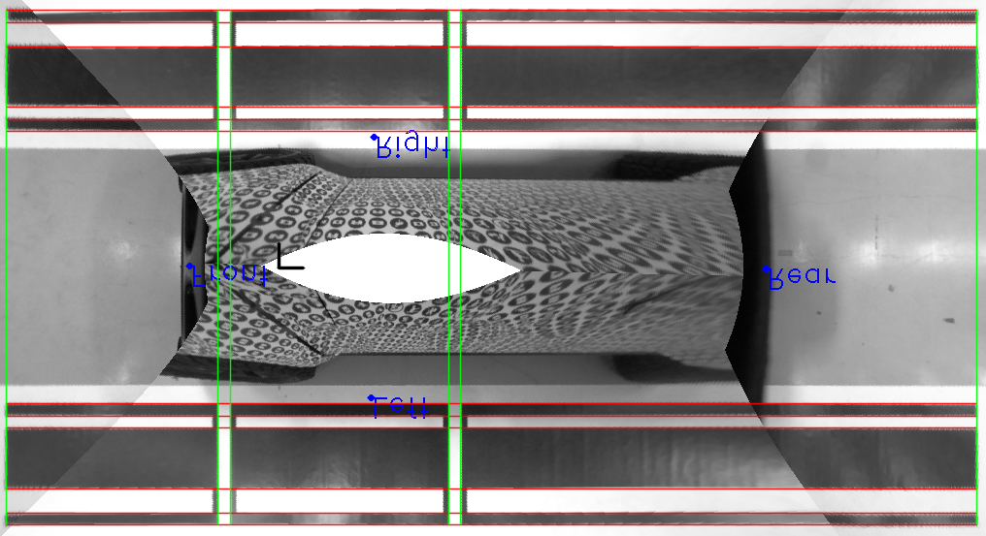

Figure 1: Bird’s eye stitch using the refined extrinsic calibration method (final calibration). The blue dots indicate the final fit position of the cameras (the text is up-side-down because the image was flipped). The black perpendicular lines near the front camera are the x axis (towards the right) and y axis (up) in the car reference frame. The red and green lines are the known positions of the calibration target lines which are aligned with the x and y axes respectively.

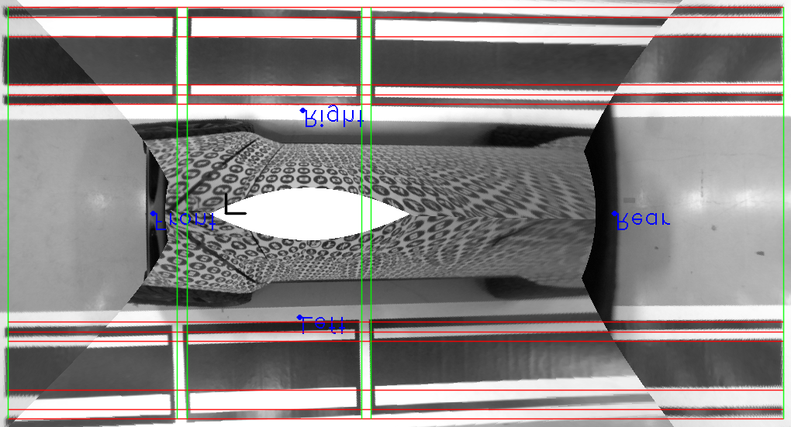

Figure 2: Bird’s eye stitch using the 2D vanishing point method

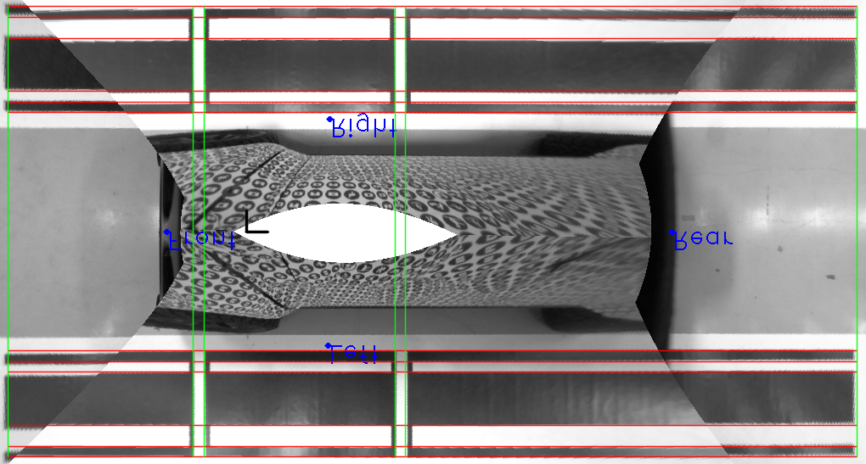

Figure 3: Bird’s eye stitch using the 3D vanishing point method (rotational fit only) + manually set translational camera position

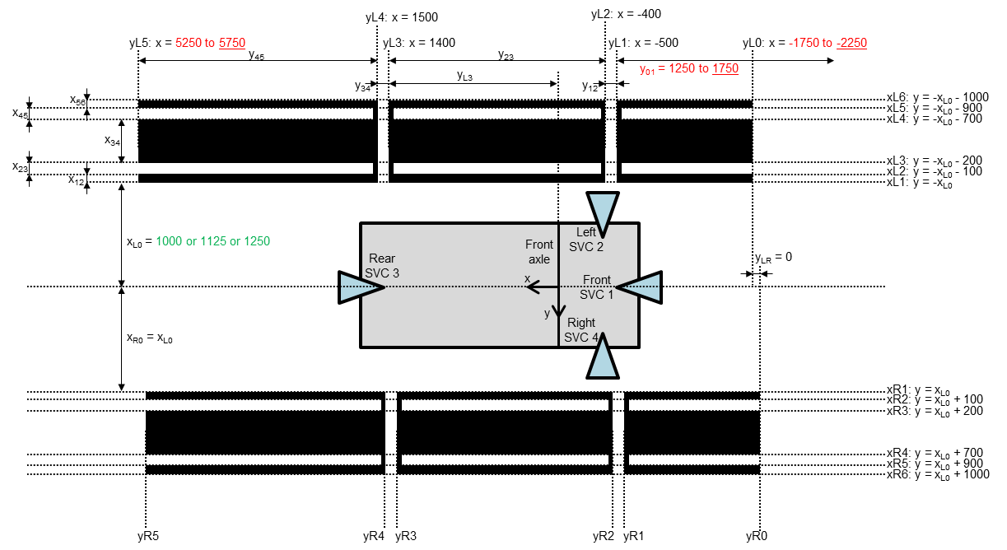

Figure 4: Calibration target known line positions. Text in green is specified ahead of time and equals the separation distance. Text in red is subject to change and this is an unresolved issue for the refined calibration method. Currently the underlined values are used successfully.

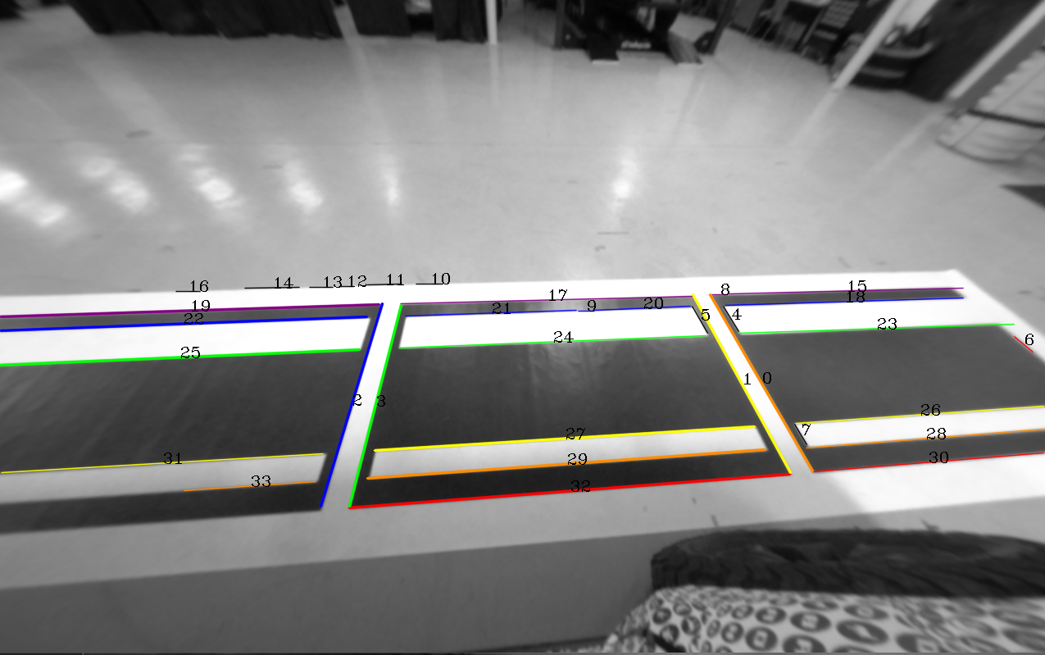

Figure 5: Debug figure in MatchLines in ExtrinsicRefinment.cpp shown for the left camera. The rainbow-colored detected lines indicate ordered matching with the calibration target lines. For the x-axis lines, the colors order is red to purple corresponding with close to far from the car. For the y-axis lines, the color order is red to purple corresponding with front to rear of the car.



Figure 6: Example image showing why 2D vanishing points sometimes fail. When the view angle of the camera (the forward camera axis) relative to the primary axes in the image is perpendicular (red lines in this image), the vanishing point will be at infinity. Hence, vanishing points should be visualized and computed in 3D.

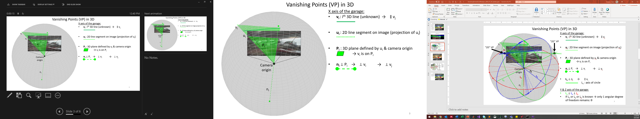

Figure 7: 3D vanishing points step 1. The variables on the figure are as follows: vi is the 3D line which corresponds to ui, the line detected in the image. Pi is the projection plane created by the camera origin and the detected line, and ni is the unit normal vector to the projection plane. The endpoints of ni lie on the unit sphere which is in gray.

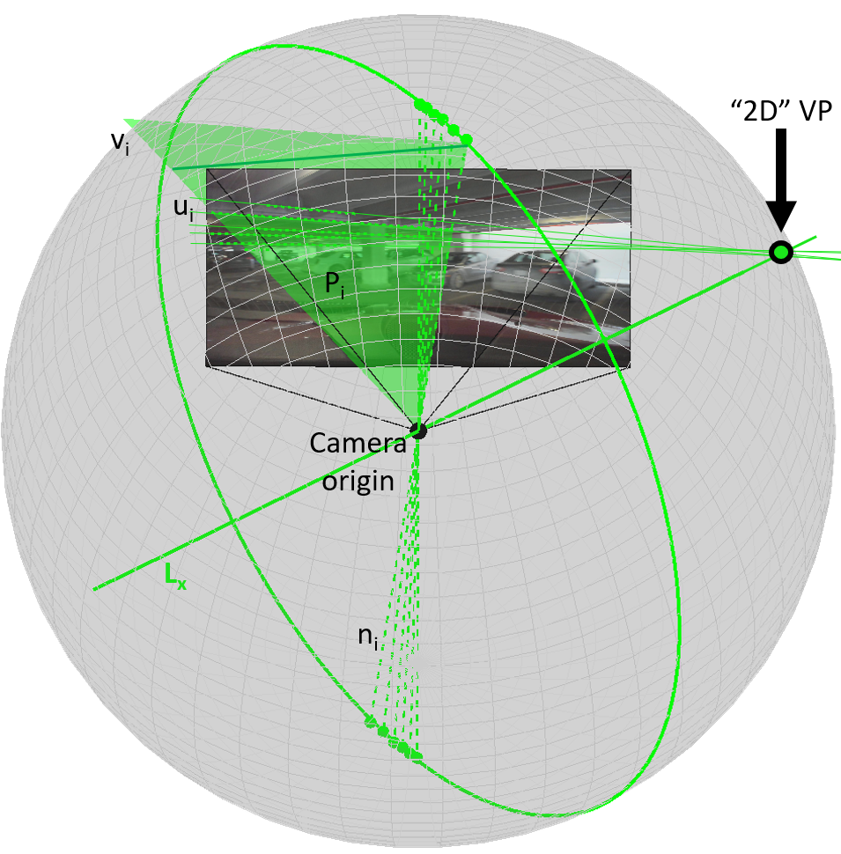

Figure 8: 3D vanishing points step 2. For multiple detected lines (ui) corresponding to the same 3D axis, the endpoints of the normal vectors to the projection plane (ni) all lie on a unit circle, which is perpendicular to the axis Lx. The 2D vanishing point lies at the intersection of Lx and the image plane. Lx is found by summing the cross products of all the pairs of normal vectors, ni. Lx is parallel to vi.

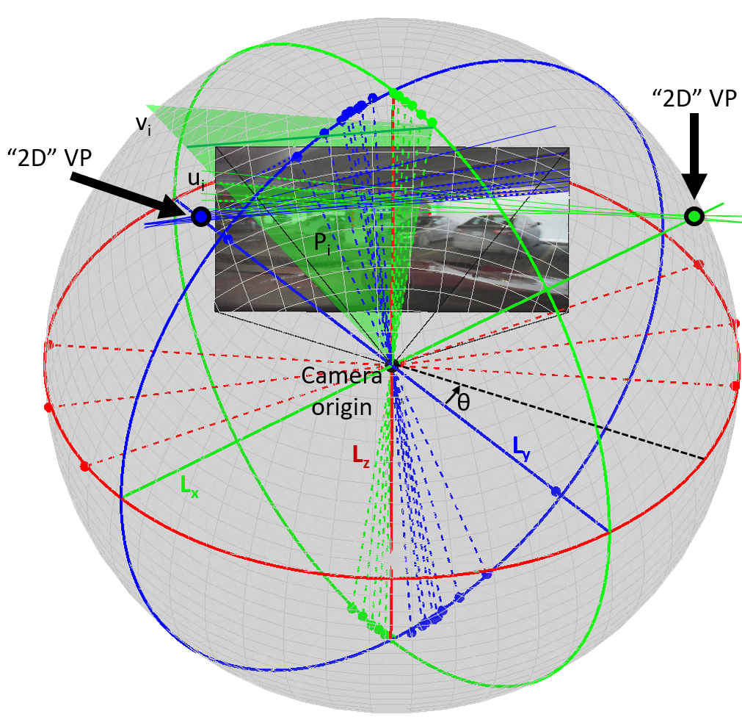

Figure 9: 3D vanishing points step 3: The three axes, Lx, Ly, and Lz, are orthonormal and correspond to the primary Manhattan-world axes in the 3D world. In the case of this extrinsic calibration, we only have lines in the x and y directions, and the z direction is the cross product of x and y axes. In this figure, we fit Lz first, so therefore, Lx and Ly are fit using only a single degree of freedom, θ.